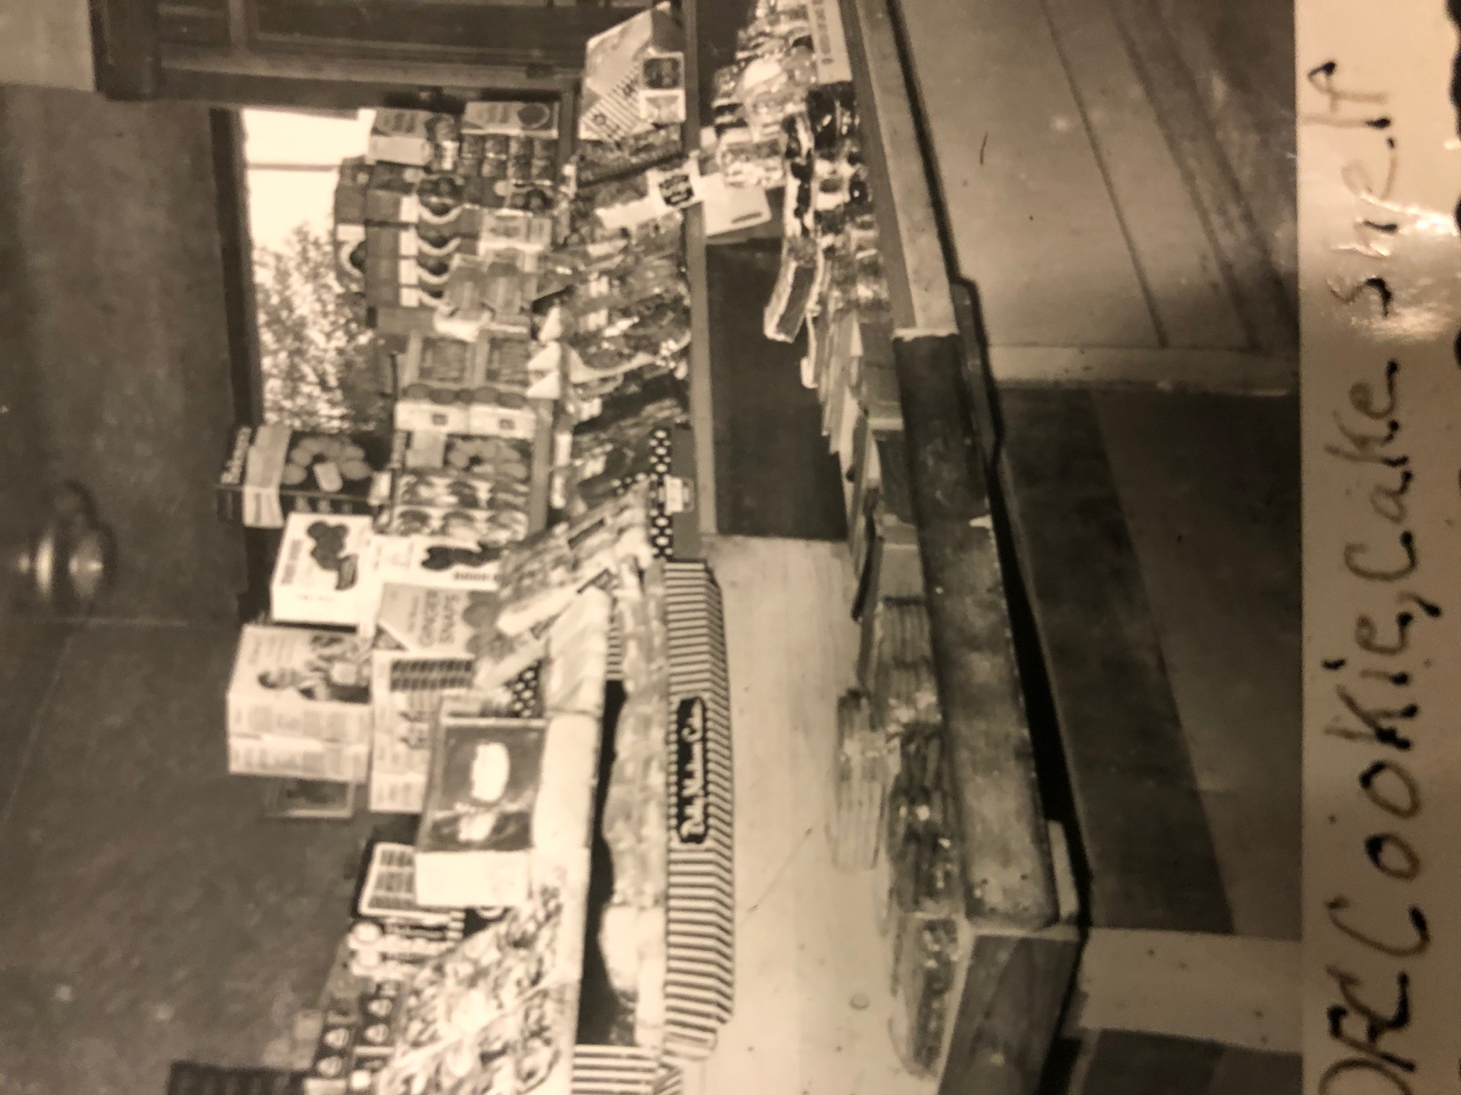
Davis Food Center (DFC) Cookie, Cake Shelf. n.d. Courtesy of the Davis Family Archives.

